**Project Planning Phase**

**Project Planning Template (Product Backlog, Sprint Planning, Stories, Story points)**

| Date | 25 October 2022 |
| --- | --- |
| Team ID | PNT2022TMID14661 |
| Project Name | AI-Powered Nutrition Analyser for Fitness Enthusiasts |
| Maximum Marks | 8 Marks |

**Product Backlog, Sprint Schedule, and Estimation (4 Marks)**

Use the below template to create product backlog and sprint schedule

| **Sprint** | **Functional Requirement (Epic)** | **User Story Number** | **User Story / Task** | **Story Points** | **Priority** | **Team Members** |
| --- | --- | --- | --- | --- | --- | --- |
| Sprint-1 | | Pre-requisites for Model Building | | --- | | USN-1 | | As a developer I have to collect different type of data possible and other data supporting the model | | --- | | 3 | High | Jino Rohit  Pranav RR |
| Sprint-1 | | Model Building | | --- | | USN-2 | | Development of the model with the prepared data set | | --- | | 4 | High | Jino Rohit  Sharat.N |
| Sprint-2 | Home page | USN-3 | As a user I can land into the main page of the website | 3 | High | Pranav RR  Sharat.N |
| Sprint-2 | Image page | USN-4 | As a user I can upload the image of the food item | 3 | High | Pranav RR  Siddharth S |
| Sprint-2 | Image prediction page | USN-5 | As a user I can view the nutritional facts  of the food image uploaded. | 3 | High | Jino Rohit  Sharat N |
| Sprint-3 | Registration | USN-6 | As a user, I can register for the application by entering my email, password, and confirming my password. | 2 | High | Pranav RR  Sharat.N |
| Sprint-3 | Login | USN-7 | As a user, I can log into the application by entering email & password | 1 | High | Pranav RR  Sharat.N |
| Sprint-3 | Logout | USN-8 | As a user, I can logout of the application | 1 | High | Jino Rohit  Sharat.N |
| Sprint-4 | Dashboard | USN-9 | As a user, I can view my daily intake  nutrition facts | 2 | Medium | Jino Rohit  Siddharth S |
| Sprint-4 | Profile | USN-10 | As a user, I can view and update my  Profile | 2 | Medium | Pranav RR  Sharat.N |
| Sprint-4 | Dashboard | USN-11 | As an administrator, I can view and  mange users, contents and everything | 1 | Medium | Pranav RR  Siddharth S |
| Sprint-4 | Feedback page | USN-12 | As a user, I can give feedback about the  pages and details | 1 | Low | Jino Rohit  Sharat.N |
| Sprint-4 | Registration | USN-13 | As a user, I can register for the application through Gmail | 1 | Medium | Pranav RR  Siddharth S |

**Project Tracker, Velocity & Burndown Chart: (4 Marks)**

| **Sprint** | **Total Story Points** | **Duration** | **Sprint Start Date** | **Sprint End Date (Planned)** | **Story Points Completed (as on Planned End Date)** | **Sprint Release Date (Actual)** |
| --- | --- | --- | --- | --- | --- | --- |
| Sprint-1 | 23 | 6 Days | 24 Oct 2022 | 29 Oct 2022 | 7 | 30 Oct 2022 |
| Sprint-2 | 23 | 6 Days | 31 Oct 2022 | 05 Nov 2022 | 16 | 10 Nov 2022 |
| Sprint-3 | 23 | 6 Days | 07 Nov 2022 | 12 Nov 2022 | 20 | 15 Nov 2022 |
| Sprint-4 | 23 | 6 Days | 14 Nov 2022 | 19 Nov 2022 | 27 | 20 Nov 2022 |

**Velocity:**

Imagine we have a 10-day sprint duration, and the velocity of the team is 20 (points per sprint). Let’s calculate the team’s average velocity (AV) per iteration unit (story points per day)

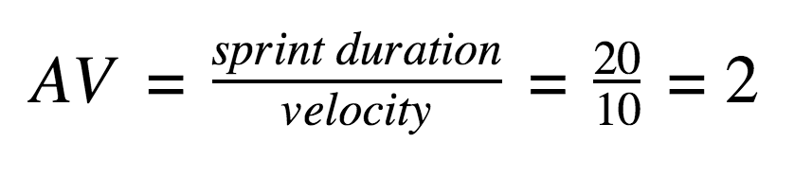

AV=24/6=4

**Burndown Chart:** 